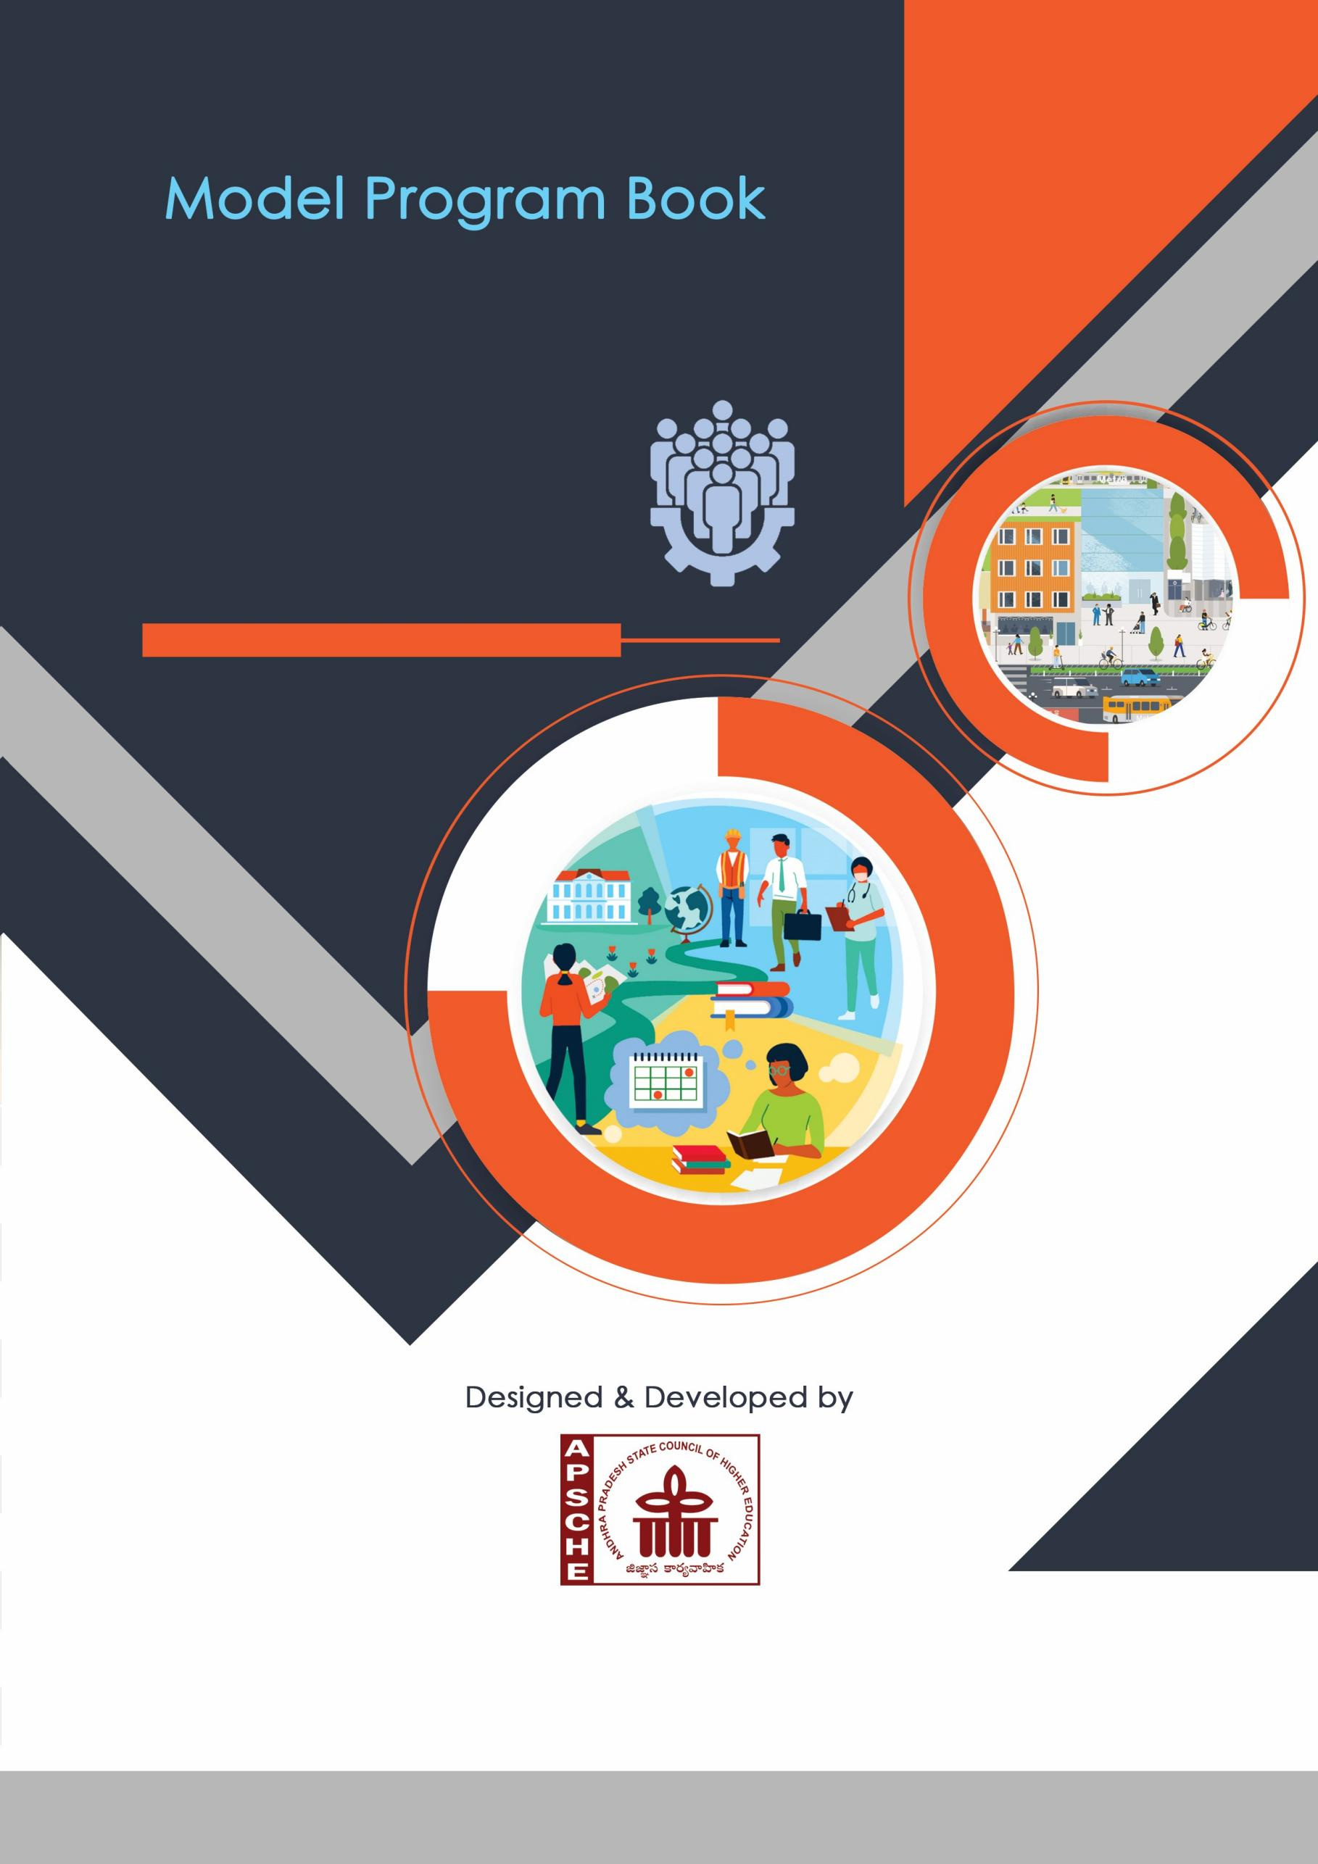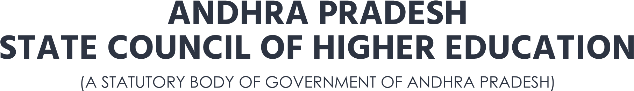

AWARENESS AND SUGGESTIVE MEASURES FOR THE IMPROVEMENT ABOUT THE CAREER OF GOVERNMENT SCHOOL STUDENTS

A Community Service report submitted in partial fulfilment of the requirements for the award of the degree of

BACHELOR OF TECHNOLOGY

in

# COMPUTER SCIENCE AND ENGINEERING

# submitted by

BHOGADI VIDHEY

(21025A0571)

Under the Guidance of

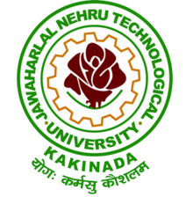Dr E. Suneetha (Asst.professor)

DEPARTMENT OF COMPUTER SCIENCE & ENGINEERING

Jawaharlal Nehru Technological University

Kakinada District, Andhra Pradesh – 533003

2022-2023

DEPARTMENT OF COMPUTER SCIENCE & ENGINEERING

Jawaharlal Nehru Technological University

Kakinada District, Andhra Pradesh – 533003

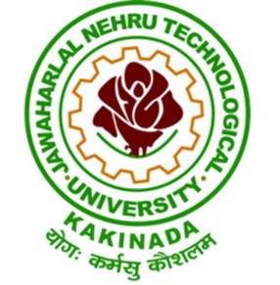

# CERTIFICATE

This is to certify that the summer internship technical report entitled “Awareness and Suggestive measures for the improvement about the career of government school students” that is being submitted by BHOGADI VIDHEY of III year I Semester bearing pin 21025A0571, in partial fulfilment for the award of the Degree of Bachelor of Technology in Computer Science and Engineering, is a record of bonafide work carried out by them.

Supervisor & Assistant Professor

**Dr E. Suneetha**

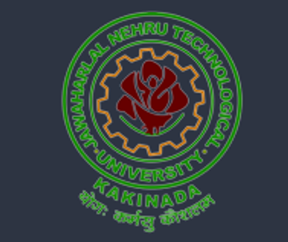

BHOGADI VIDHEY

Jawaharlal Nehru Technological University

21025A0571

6 Weeks (180 hrs)

21/11/2022

01/01/2023

Municipal Corporation Upper Primary School, Reserve Police Lines, Kakinada, 533-003.

**PROGRAM**

**BOOK**

**FOR**

**COMMUNITY**

**SERVICE**

**PROJECT**



**University**



2022-23

**Jawaharlal Nehru Technological**

**Instructions to Students for Community Service Project**

**Please read the detailed Guidelines on Community Service Project hosted on the website of AP State Council of Higher Education** [**https://apsche.ap.gov.in**](https://apsche.ap.gov.in/)

**Link:**

[**https://apsche.ap.gov.in/Pdf/Guidelines%20for%20the%20OJT%20Internship**](https://apsche.ap.gov.in/Pdf/Guidelines%20for%20the%20OJT%20Internship%20Community%20Service%20Project.pdf)

[**%20Community%20Service%20Project.pdf**](https://apsche.ap.gov.in/Pdf/Guidelines%20for%20the%20OJT%20Internship%20Community%20Service%20Project.pdf)

1. It is mandatory for all the students to complete 2 months (180 hours) of Community Service Project as a part of the 10-month mandatory internship/on the job training.
2. Consider yourself a committed volunteer in the community, you work with.
3. Every student should identify the village/community/habitation for Community Service Project (CSP) in consultation with the College Principal/the authorized person nominated by the principal.
4. Report to the community/habitation as per the schedule given by the College. You must make your own arrangements for transportation to reach the community/habitation.
5. You will be assigned a Faculty Guide from your College. He/she will be creating a WhatsApp group with your fellow volunteers. Post your daily activity done and/or any difficulty you encounter during the programme.
6. You should maintain punctuality in attending the CSP. Daily attendance is compulsory.
7. You are expected to learn about the community/habitation and their problems.
8. Know the leaders and the officials of the community/habitation.
9. While in the project, always wear your College Identity Card.
10. If your college has a prescribed dress as uniform, wear the uniform daily.
11. Identify at least five learning objectives in consultation with your Faculty Guide. These learning objectives can address:
    * Information about the community, including the realities and

problems of the society.

* + Need for creating awareness on socially relevant aspects/programs.
  + Acquiring specific Life Skills.
  + Learning areas of application of knowledge and technologies related to your discipline.
  + Identifying developmental needs of the community/habitation.

1. Practice professional communication skills with team members, and with the leaders and officials of the community. This includes expressing thoughts and ideas effectively through oral, written, and non-verbal communication, and utilizing listening skills.
2. Be regular in filling up your Program Book. It shall be filled up in your own handwriting. Add additional sheets wherever necessary.
3. At the end of Community Service Project, you shall be evaluated by the person in-charge of the community/habitation to whom you report to.
4. There shall also be an evaluation at the end of the community service by the Faculty Guide and the Principal.
5. Do not indulge in any political activities.
6. Ensure that you do not cause any disturbance to the inhabitants or households during your interaction or collection of data.
7. Be cordial but not too intimate with the people you come across during your service activities.
8. You should understand that during this activity, you are the ambassador of your college, and your behaviour during the community service programme is of utmost importance.
9. If you are involved in any discipline related issues, you will be withdrawn from the programme immediately and disciplinary action shall be initiated.
10. Do not forget to keep up your family pride and prestige of your college.

1. Remember that you are rendering valuable service to the society and your role in the community development will become part of the history of the community.

# Community Service Project Report

**Submitted in accordance with the requirement for the degree**

**of** Batchelor of Technology

**College Name:** Jawaharlal Nehru Technological University

**Department:** Computer Science and Engineering

**Name of the Faculty Guide:** Dr E. Suneetha

**Duration of the CSP:** 6weeks(21/11/2022 **-** 01/01/2023)

**Name of the Student:** BHOGADI VIDHEY

**Programme of Study:** R20

**Year of Study:** IIIrd year 1st semester

**Register Number:** 21025A0571

**Date of Submission:** 13/02/2023

# Student’s Declaration

**I,** BHOGADI VIDHEY**, a student of** R20 **Program, Reg. No.** 21025A0571 **of the Department of** Computer Science and Engineering**,** Jawaharlal Nehru Technological University **do hereby declare that I have completed the mandatory community service from** 21/11/2022 **to** 01/01/2023 **in** Municipal Corporation Upper Primary School, **under the Faculty Guideship of** Dr E. Suneetha**, Department of** Computer Science and Engineering **in College** Jawaharlal Nehru Technological University.

**(Signature and Date)**

**Endorsements**

Faculty Guide:

**Dr E. Suneetha**

Head of the Department:

**Dr O. Srinivasa Rav**

Principal:

**Dr M. H. M. Krishna Prasad**

**Certificate from Official of the Community**

**This is to certify that** BHOGADI VIDHEY **Reg. No** 21025A0571 **of** Jawaharlal Nehru Technological University **underwent community service in** Municipal Corporation Upper Primary School, **from** 21/11/2022 **to** 01/01/2023 **The overall performance of the Community Service Volunteer during his/her community service is found to be** good**.**

**Authorized Signatory with Date and Seal**

**Acknowledgements**

With great pleasure I want to take this opportunity to express my heartfelt gratitude to all the people who helped in completing this Internship.

I am very grateful to my project guide **Dr E. Suneetha**, Assistant

Professor, Department of Computer Science & Engineering, for sharing his truthful and illuminating views on a number of issues during the Internship.

I also extend my gratitude to our HOD **Dr O. Srinivasa Rav**, for his valuable guidance and support on completion of this Internship.

We are highly indebted to Principal, **Dr M. H. M. Krishna Prasad**, for giving us the permission to attend and complete this Internship.

I would like to express my heartfelt thanks to **AICTE** for providing us the beautiful opportunity of doing an internship.

BHOGADI VIDHEY

(21025A0571)

## Contents

|  |  |
| --- | --- |
| Name of the Chapter | Page Number |
| **CHAPTER 1:** EXECUTIVE SUMMARY | 12 |
| **CHAPTER 2:** OVERVIEW OF THE COMMUNITY | 13-14 |
| **CHAPTER 3:** COMMUNITY SERVICE PART   1. ACTIVITY LOG FOR THE FIRST WEEK 2. WEEKLY REPORT -1 3. ACTIVITY LOG FOR THE SECOND WEEK 4. WEEKLY REPORT-2 5. ACTIVITY LOG FOR THE THRID   WEEK   1. WEEKLY REPORT-3 2. ACTIVITY LOG FOR THE FOURTH WEEK 3. WEEKLY REPORT-4 4. ACTIVITY LOG FOR THE FIFTH WEEK 5. WEEKLY REPORT-5 6. ACTIVITY LOG FOR THE SIXTH WEEK 7. WEEKLY REPORT-6 | 15-27 |
| **CHAPTER 4:** OUTCOMES DESCRIPTION   1. Describe the problems you have identified in the community 2. Short-Term, Long-term Action Plan 3. Description of the Community awareness programmes conducted   w.r.t the problems and their outcomes.  4) Report of the Mini Project work. | 28-45 |
| **CHAPTER 5:** RECOMMENDATIONS AND CONCLUSIONS | 46-47 |
| Student Self Evaluation | 48 |
| Evaluation by the In Charge of the community | 49 |
| Photos and videos links | 50-52 |
| Evaluation (Internal Assessment) | 53-55 |

### CHAPTER 1: EXECUTIVE SUMMARY

An executive summary on a career guidance internship for high school students should provide a brief overview of the program's purpose, structure, key components, student experiences and outcomes. The following is an executive summary of our Community Service Project:

**Purpose:** The career guidance internship for high school students was designed to provide hands-on learning opportunities and exposure to various careers, as well as to offer guidance and support for students as they plan for their future.

**Structure:** The internship program ran for 6 weeks, during which students participated in a variety of activities, including job shadowing, informational interviews, and workshops focused on skills development and career exploration. Students were paired with mentors from their desired career field who provided guidance and support throughout the program.

**Key Components:** During the internship, students worked in teams under the supervision of professionals, who acted as mentors and provided guidance and feedback throughout the program. Students also attended workshops and seminars on topics such as resume writing, interview skills, and networking.

**Student Experiences:** The internship program involved students participating in hands-on projects, shadowing professionals in their chosen field, and attending workshops and seminars to learn about different careers and industries. The students also had the opportunity to network with professionals and learn about the skills and qualifications required for different careers.

**Outcomes:** At the conclusion of the program, students reported a greater understanding of their personal interests and strengths, as well as a better understanding of various careers and the steps necessary to pursue them. They also reported feeling more confident and prepared for the future, with many stating that they had a clearer direction for their career plans.

Overall, the career guidance internship for high school students was a successful and valuable experience, providing students with valuable exposure to various careers, as well as the skills and knowledge necessary to make informed decisions about their future.

### CHAPTER 2: OVERVIEW OF THE COMMUNITY

The Municipal Corporation Upper Primary School is the community we had selected as a part of our Community Service Project. It is located near Bhanugudi Junction, Police Quarters, Kakinada, Andhra Pradesh, 533003. This school consists of fifteen teachers, one headmaster and 300 students.

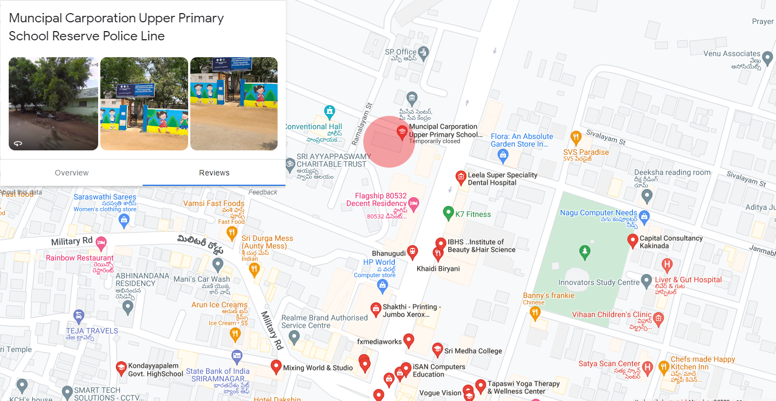Most of the students are orphanage kids who lack knowledge about the present trend of the world and don’t have proper guidance. The socio-economic conditions of a high school refer to the various social, economic, and cultural factors that can impact the educational experience of students in that school. Some of the most common socio-economic factors that can affect a high school include:

|  |  |
| --- | --- |
| Location | |
| Location | Kakinada |
| State | Andhra Pradesh |
| Country | India |
| Geographic coordinates | 16.972993°N 82.236535°E |

**Family income:** Low-income families often struggle to provide their children with the resources and support they need to succeed in school, including adequate food, housing, and healthcare.

**Parental education:** Children of parents with higher levels of education tend to have greater academic success and access to educational resources.

**Neighbourhood environment:** The quality of the neighbourhood in which a high school is located can play a significant role in students' experiences and outcomes.

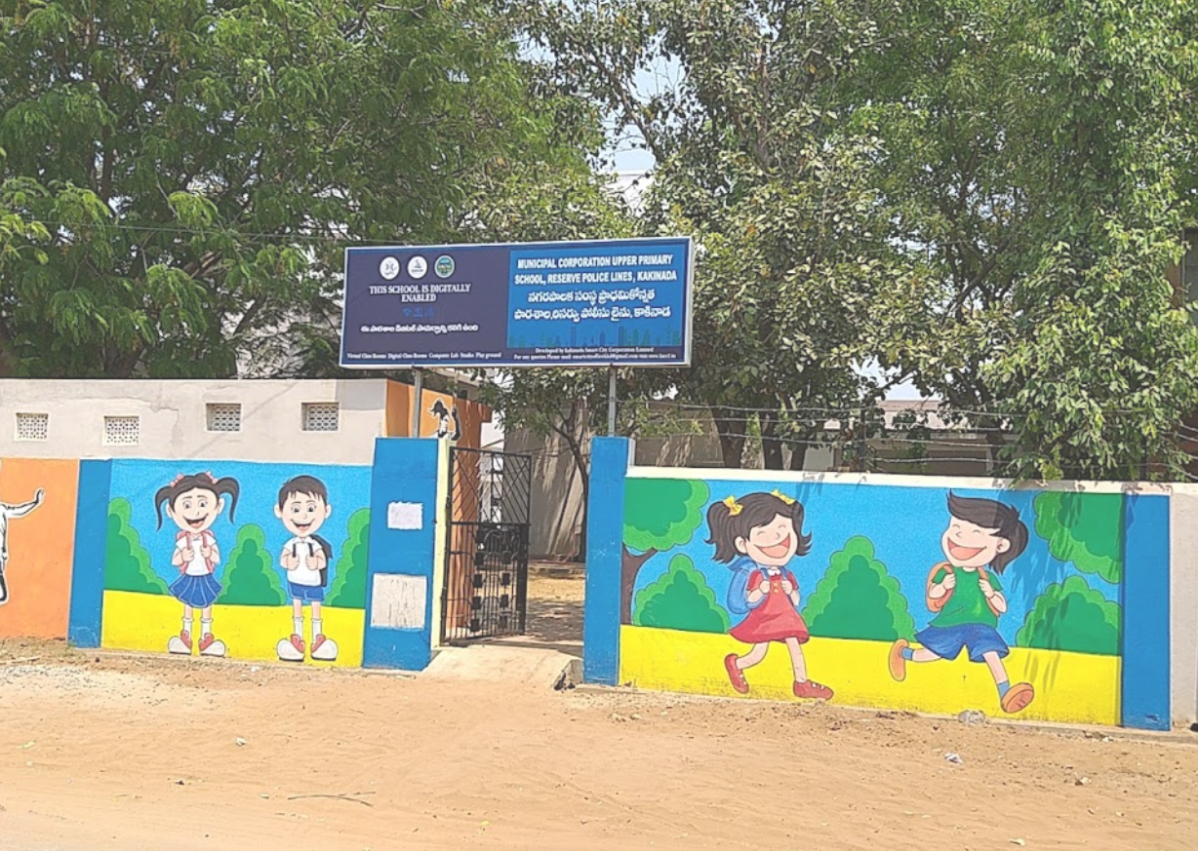**Cultural diversity:** High schools that serve a diverse student population can offer a rich learning experience, but can also pose challenges for students and teachers in terms of cultural understanding and communication.

**Access to technology:** The availability and use of technology, such as computers and the internet, can greatly impact students' ability to complete assignments and access information.

**Teacher quality:** High-quality teachers can play a significant role in helping students succeed academically and socially, while ineffective teachers can have a negative impact on students' experiences and outcomes.

These and other socio-economic conditions can affect the academic achievement and opportunities of students in a high school, and it is important for schools, educators, and policymakers to be aware of and address these challenges in order to support student success.

### CHAPTER 3: COMMUNITY SERVICE PART

Community service can play a significant role in educating children and helping them to develop important skills and values. Here are some ways in which individuals can become involved in community service related to education:

* **Tutoring and mentoring:** We individuals can volunteer as tutors or mentors to help students with homework, reading, and other subjects. This can also provide an opportunity to build positive relationships with young people.
* **Classroom assistance:** we Individuals volunteered to assist teachers in the classroom by grading papers, organizing materials, or helping with class projects.
* **Reading programs:** we taught then the importance of participating in programs that promote reading and literacy can help children develop important skills and foster a love of learning.
* **College and career readiness programs**: we Individuals volunteered to help students explore and prepare for college and career opportunities, providing guidance and support along the way.

By becoming involved in community service related to education, individuals can make a positive impact on the lives of children and help prepare the next generation for success.

#### ACTIVITY LOG FOR THE FIRST WEEK

|  |  |  |  |
| --- | --- | --- | --- |
| **Day**  **&**  **Date** | **Learning Outcome** | **Brief description of the daily activity** | **Person In Charge**  **Signature** |
| Day – 1 | Topic Selection | Choosing a topic for our CSP from vast number of topics that could potentially help the society. |  |
| Day - 2 | Location Selection | Selecting a location that truly needs our support and also an area that could help us to implement our ideas better. |  |
| Day – 3 | Seeking Permissions | Seeking the permissions from our management and knowing the place before hand before visiting. |  |
| Day – 4 | Introduction Phase 1 | Introducing ourselves and the purpose of meeting them. |  |
| Day – 5 | Introduction Phase 2 | Interactive session with students regarding their ambitions, desires and passions. |  |
| Day –6 | Introduction Phase 3 | Giving a on introduction Career Guidance. Explaining why and how it plays an important role |  |

|  |
| --- |
| **WEEKLY REPORT**  Week-1 (From: 21/11/2022 To: 27/11/2022) |
| **Objective of the Activity Done:** Selection of topic and area where the career guidance  should be given. |
| **Detailed Report:**  A community service project is a volunteer effort aimed at improving the well-being and quality of life of individuals and communities. Community service projects can involve a wide range of activities, such as helping out at a local food bank, organizing a clean-up event, tutoring students, or volunteering at a hospital or clinic. When choosing a community service project, it's important to consider your own interests, skills, and schedule, as well as the needs of the community. It's also important to choose a project that you can realistically commit to and that aligns with your values and beliefs. Overall, participating in a community service project can be a rewarding and fulfilling experience that benefits both the individual and the community. This will increase your chances of success and make the experience more enjoyable for you and those you are serving.  Hello students, today we'll be talking about the importance of education and how we can use community service to make a positive impact in this area. Education is a fundamental right and plays a crucial role in shaping our future and the future of our communities.  **Question 1:** Can you think of any ways in which education is important for individuals and communities?  **Question 2:** How can we use community service to support education?  **Question 3:** What are some of the challenges that students in our community might face in accessing education?  Education is a fundamental right and plays a crucial role in shaping our future and the future of our communities. Through community service, we have the power to make a positive impact in this area and support students in accessing the education they need to succeed. Let's work together to make a difference!  This interactive session can help students understand the importance of education and the role they can play in supporting it through community service. It can also help them develop critical thinking and problem-solving skills as they work together to identify challenges and solutions. |

#### 

#### ACTIVITY LOG FOR THE SECOND WEEK

|  |  |  |  |
| --- | --- | --- | --- |
| **Day**  **&**  **Date** | **Learning Outcome** | **Brief description of the daily activity** | **Person In Charge**  **Signature** |
| Day – 1 | knowing student’s interests. | We lead the kids through various activities to know their interests, skills and values. |  |
| Day - 2 | Self-awareness programmes. | We conducted a self – awareness program to make more informed decisions about their future.  These include meditation and feedback from other |  |
| Day – 3 | Skills assessment programs. | We accomplished skills assessment program to help the kids identify their skills and abilities. Like aptitude test and personality test |  |
| Day – 4 | Self – assessment programs. | We implemented self – assessment through various methods like surveys and questionnaires |  |
| Day – 5 | Understanding the strengths and weaknesses. | Helping kids in understand their strengths and weaknesses through their confidence levels in doing activities. |  |
| Day –6 | Reasons we explained why understanding the strengths and weaknesses is important. | We explained why understanding the strengths and weaknesses is important for career planning as it makes better match between skills and careers |  |

|  |
| --- |
| **WEEKLY REPORT**  Week-2 (From: 28/11/2022 To: 04/12/2022) |
| **Objective of the Activity Done:**  Activities to know student’s interests. |
| **Detailed Report:**  **1) Interest Surveys:** Interest surveys are a great way for students to learn about their interests and how they can be translated into career paths. These surveys typically ask questions about various activities, hobbies, and subjects, and use the answers to suggest career options that align with the student's interests.  **2) Values Clarification:** Values clarification is an activity that helps students understand their personal values and how they can be incorporated into their career choices. Students are asked to reflect on what is important to them, such as family, community, creativity, or financial stability, and how these values can influence their career decisions. Self-awareness is a critical component of making informed decisions about one's future, and these activities can help students develop greater self-awareness and clarity about their interests, skills, values, and goals.  **Skills assessments are a valuable tool for helping students identify their skills and abilities and make informed decisions about their future education and career paths.**  **1) Aptitude Tests:** Aptitude tests measure a student's natural abilities, such as verbal reasoning, mathematical ability, spatial perception, and memory. These tests can help students understand their strengths and weaknesses and identify potential career paths that align with their abilities.  **2) Personality Tests:** Personality tests measure a student's characteristics, such as introversion or extroversion, openness, conscientiousness, and emotional stability. These tests can help students understand their tendencies, preferences, and work styles, and identify careers that align with their personalities. Self-assessment is a critical component of the career exploration process and can help students gain a deeper understanding of their interests, skills, and values.   * Surveys and Questionnaires * Reflective Journaling * Interest Inventories |

#### ACTIVITY LOG FOR THE THIRD WEEK

|  |  |  |  |
| --- | --- | --- | --- |
| **Day**  **&**  **Date** | **Learning Outcome** | **Brief description of the daily activity** | **Person In Charge**  **Signature** |
| Day – 1 | session on Career Exploration. | We carried out a brief interactive session on Career exploration which helps the kids to learn about different paths. |  |
| Day - 2 | Introducing various career options. | Introducing various career options for kids so that they make more informed decisions about their future. |  |
| Day – 3 | Informed about Education and training required for various career options. | We informed the kids the education and training required for various career options. |  |
| Day – 4 | Informed details about Medicine, Law, Engineering. | We informed the details regarding the three different major streams like medicine, engineering, law. |  |
| Day – 5 | Students research. | We asked the kids to research careers that interest them by helping them. Provided the necessary resources |  |
| Day –6 | open minded in the aspect of career exploration. | Discussed the importance of being open minded in the aspect of career exploration. |  |

|  |
| --- |
| **WEEKLY REPORT**  Week-3 (From: 05/12/2022 To: 11/12/2022) |
| **Objective of the Activity Done:** Interactive session on career exploration. |
| **Detailed Report:**  We carried out a brief interactive session on Career exploration which helps the kids to learn about different paths and choose a career that path that is a good fit for them.  During the interactive session, you can introduce students to different career paths and help them learn about the requirements for each one. You can also encourage students to think about their interests, skills, and values when considering different career options. Some activities that can be used to support career exploration include:  **1) Career research:** Encourage students to research different careers and learn about the education, skills, and experience required for each one. They can use online resources, such as the U.S. Bureau of Labour Statistics' Occupational Outlook Handbook, to gather information**.**  **2) Career shadowing:** Encourage students to connect with professionals in the fields they are interested in and learn more about their careers through job shadowing or informational interviews.  **3) Career fairs:** Attend local career fairs or arrange a virtual career fair where students can learn about different careers from professionals in various fields.  **4) Career assessments:** Encourage students to take career assessments, such as the Myers-Briggs Type Indicator or the Strong Interest Inventory, to help them identify careers that align with their interests, skills, and values. After completing 10th grade, there are a variety of courses that students can pursue, depending on their interests and career goals. Some of the most common options include:   * Higher Secondary Education (HSE) * Vocational courses * Diploma courses * Polytechnic courses * ITI courses |

#### ACTIVITY LOG FOR THE FOURTH WEEK

|  |  |  |  |
| --- | --- | --- | --- |
| **Day**  **&**  **Date** | **Learning Outcome** | **Brief description of the daily activity** | **Person In Charge**  **Signature** |
| Day – 1 | Reasons why being open minded is important in career exploration. | We explained the some of the reasons why it is important to be open-minded in choosing career options cause different paths can lead to success |  |
| Day - 2 | Filling gaps in knowledge through asking doubts. | We introduced a concept of asking doubts so that it will clarify the understanding and fill any gaps in knowledge. Through they identify misconceptions and expand their knowledge |  |
| Day – 3 | We introduced a concept of Networking through connections. | We rolled out another concept like Networking in Career Guidance as it helps the students to gain valuable insights and connect with employers, mentors, and peers. |  |
| Day – 4 | Experiencing different career options. | We presented the importance of experiencing different career options in order to make an informed decision. |  |
| Day – 5 | Reasons why it is important to experiencing different career options. | We suggested reasons why it’s important to experience different career options before choosing one cause some times having idea about job is different from doing a job |  |
| Day –6 | After all we asked students to create a list of all potential options. | We asked the students to create a list of all potential options which helps them make all informed decisions about their future. |  |

|  |
| --- |
| **WEEKLY REPORT**  Week-4 (From: 12/12/2022 To: 18/12/2022) |
| **Objective of the Activity Done:** Experiencing different career options. |
| **Detailed Report:**  Being open-minded is an important aspect of career exploration because it allows individuals to consider a wider range of career options and helps them make better informed decisions. Some of the key benefits of being open-minded during career exploration include:  **1) Expanded Career Options:** By keeping an open mind, individuals can explore a variety of career paths and consider options they may not have considered before.  **2) Encourages Exploration:** Being open-minded encourages individuals to take risks and explore new possibilities, rather than limiting themselves to a narrow set of options.  **3) Promotes Personal Growth:** Keeping an open mind can help individuals grow and develop new skills and perspectives, which can be valuable in any career.  **4) Better Career Decisions:** By considering a variety of options, individuals can make more informed decisions about their future careers and increase the likelihood of finding a good fit.  Asking questions and seeking clarification is an important part of the career exploration process. It allows individuals to better understand the various career options available to them, as well as the skills and qualifications required for each. Asking questions can also help individuals to make more informed decisions about their future careers.  Some key benefits of asking questions during the career exploration process include:  **1) Clearing Up Confusion:** Asking questions can help to clear up any confusion or misunderstandings about a particular career or industry.  **2) Gathering Information:** Questions can help individuals gather information about the day-to-day tasks, responsibilities, and requirements of a particular career.  **3) Identifying Potential Challenges:** By asking questions, individuals can gain a better understanding of the challenges and obstacles they may face in a particular career, and make more informed decisions. |

#### ACTIVITY LOG FOR THE FIFTH WEEK

|  |  |  |  |
| --- | --- | --- | --- |
| **Day**  **&**  **Date** | **Learning Outcome** | **Brief description of the daily activity** | **Person In Charge**  **Signature** |
| Day – 1 | Making a Career Plan. | We explained them about the various steps involved in making a career plan. Initiation, exploration, preparation and many more |  |
| Day - 2 | The prerequisites to execute a Career Plan. | We discussed about choosing the career plans for individuals including education, training and certificate requirements. |  |
| Day – 3 | Understand SMART goals. | Assisted them that it is essential to create time line for career plan by using SMART goals. Specific, measurable, achievable, relevant and time |  |
| Day – 4 | Understand the importance of a Career Plan. | We explained the importance of having a plan and sticking to it in order to reach their career goals. The dedication and determination needed for it. |  |
| Day – 5 | Know various fields to choose a Career Plan. | We guided them that there are various fields to make a career plan and assisted them to choose one based on their interest and necessity. |  |
| Day –6 | Understand the importance of focus on education | We emphasized the importance of education and encourage the kids to focus on their studies. |  |

|  |
| --- |
| **WEEKLY REPORT**  Week-5 (From: 19/12/2022 To: 25/12/2022) |
| **Objective of the Activity Done:**  explained the steps involved in making a career plan. |
| **Detailed Report:**  We explained them about the steps involved in making a career plan such as:   * Initiation * Exploration * Decision-making * Preparation * Implementation   We discussed about choosing the career plans for individuals including education, training and certificate requirements.  Assisted them that it is essential to create time line for career plan by using SMART goals. SMART stands for   * Specific * Measurable * Achievable * Relevant * Time -Bound   Defining these parameters as they pertain to your goal helps ensure that your objectives are attainable within a certain time frame.  This approach eliminates generalities and guesswork, sets a clear timeline, and makes it easier to track progress and identify missed milestones.  We explained the importance of having a plan and sticking to it in order to reach their career goals. We guided them that there are various fields to make a career plan and assisted them to choose one based on their interest and necessity.  We emphasized the importance of education and encourage the kids to focus on their studies. |

#### ACTIVITY LOG FOR THE SIXTH WEEK

|  |  |  |  |
| --- | --- | --- | --- |
| **Day**  **&**  **Date** | **Learning Outcome** | **Brief description of the daily activity** | **Person In Charge**  **Signature** |
| Day – 1 | Importance of preparing for future from early years | We discussed that making a career plan is not essentially enough but preparing for future is also necessary. The early we start the better the understanding of needs and ease of fulfillment |  |
| Day - 2 | Prerequisites for future preparation | We guided them about the importance of volunteer work, internships in preparing for future. |  |
| Day – 3 | Self-discovery through the years | We encouraged the kids to continue their research and self-discovery and told them it is a continuous process |  |
| Day – 4 | pursuing their goals. | We Motivated them to pursue their goals and told the importance of discipline in order to achieve their goals |  |
| Day – 5 | Understand the process of career choosing | We reminded them that the process of career choosing is ongoing process and will likely involve many conversations and experiences over time. |  |
| Day –6 | Feedback and summarization. | We summarized the program by explaining key points and held a final doubt session and motivated them to stick to their goals and greeted them with well wishes for their future |  |

|  |
| --- |
| **WEEKLY REPORT**  Week-6 (From: 26/12/2022 To: 01/01/2022) |
| **Objective of the Activity Done:**  Feedback and Summarization. |
| **Detailed Report:**   * We discussed that making a career plan is not essentially enough but preparing for future is also necessary. * We guided them about the importance of volunteer work, internships in preparing for future. * We encouraged the kids to continue their research and self-discovery. * We Motivated them to pursue their goals and told the importance of discipline. * We reminded them that the process of career guidance is ongoing process and will likely involve many conversations and experiences over time. * We asked about the experience of spending their quality time with us. We summarized the program by explaining key points and encouraging kids. We also held a doubt clarification session to ensure that the kids understood everything that we have guided. |

**CHAPTER 4: OUTCOMES DESCRIPTION**

Kakinada Mandal of East Godavari district has **total population of 312,538** as per the Census 2011. Out of which 152,571 are males while 159,967 are females. In 2011 there were total 82,333 families residing in Kakinada Mandal. The **Average Sex Ratio of Kakinada Mandal is 1,048.**

As per Census 2011, all of the population of Kakinada Mandal lives in rural areas. The average literacy rate in rural area is 80.6% and the sex ratio of Kakinada Mandal is 1,048.

The population of Children of age 0-6 years in Kakinada Mandal is 29698 which is 10% of the total population. There are 15041 male children and 14657 female children between the age 0-6 years. Thus, as per the Census 2011 the Child Sex Ratio of Kakinada Mandal is 974 which is less than Average Sex Rati o (1,048) of Kakinada Mandal.

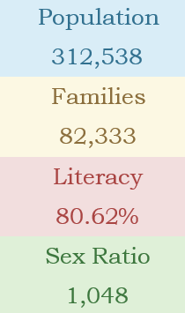The total literacy rate of Kakinada Mandal is 80.62%. The male literacy rates

is 76% and the female literacy rate is 70.07% in Kakinada Mandal.

As per the Population Census 2011 data, following are some quick facts about Kakinada Mandal.

Average literacy rate of Kakinada Mandal in 2011 were 80.62% in which, male and female literacy were 84.31% and 77.14% respectively. Total literate in Kakinada Mandal were 228,034 Of which male and female were 115,949 and 112,085 respectively.

**Questionnaire prepared for the survey**

1) What is your current grade level in high school?

a. 7th grade

b. 8th grade

c. 9th grade

d. 10th grade

2) Have you given any thought to your future career?

a. Yes b. No

3) What is your top three career interests?

a. ____________

b. ____________

c. ____________

4) What subjects do you enjoy the most in school?

a. ____________

b. ____________

c. ____________

5) Have you taken any career assessments or interest surveys?

a. Yes b. No

6) Have you discussed your career interests with a teacher or guidance counsellor?

a. Yes b. No

7) Have you participated in any career-related activities or programs (e.g. job shadowing, internships, etc.)?

a. Yes b. No

8) What resources have you used to explore potential careers? (e.g. websites, books, etc.)

a. ____________

b. ____________

c. ____________

9) How confident do you feel in making a decision about your future career?

a. Very confident

b. Somewhat confident

c. Not very confident

d. Not at all confident

10) Do you feel like you have enough information to make a well-informed decision about your future career?

a. Yes b. No

11) How important do you believe it is to choose a career that aligns with your interests and values?

a. Very important

b. Somewhat important

c. Not very important

12) Is there anything that you would like to add or that you feel is important for us to know about your career interests and plans?

____________________________________________________________________________________________________________________________________________

13) What are your long-term career goals?

a. corporate job

b. public service

c. Creative arts

d. Other (please specify)

14)What subjects do you enjoy the most in school?

a. Mathematics

b. Science

c. History

d. Other (please specify)

15) What extracurricular activities do you participate in?

a. Sports

b. Drama

c. Student government

d. Other (please specify)

16) What do you see as your strengths?

a. Leadership

b. Creative thinking

c. Problem-solving

d. Other (please specify)

17) What are your values and priorities in life?

a. Helping others

b. Pursuing personal happiness

c. financial stability

d. Other (please specify)

18) What industries or fields are you interested in exploring as a potential career?

a. Healthcare

b. Education

c. Business

d. Environmental conservation

e. Other (please specify)

19) What skills do you want to develop or improve upon in the future?

a. public speaking

b. Team collaboration

c. Technology proficiency

d. Other (please specify)

20) Are you interested in attending a 4-year college, community college, trade school, or considering another option?

a. 4-year college

b. Community college

c. Trade school

d. Other (please specify)

21) Do you have any questions or concerns about pursuing higher education or entering the workforce?

a. Yes b. No

22) What kind of work environment do you prefer?

a. Fast-paced and challenging

b. Collaborative and team-oriented

c. Structured and well-organized

d. Other (please specify) _________

23) What kind of salary and benefits are important to you in a career?

a. High salary

b. good benefits package

c. Flexible schedule

d. Other (please specify) _________

#### Describe the problems you have identified in the community

I and my team members physically visited to schools and interact with the community. However, based on my training data and general knowledge, I can provide some common issues that are faced by students and the community in regards to career guidance:

**Lack of Awareness:** Many students and individuals in the community are not been aware of the various career options available to them. They had limited knowledge about the job market and the skills required for different careers.

**Limited Resources:** Schools and communities had no access to sufficient resources, such as career counsellors, resources for job training, or up-to-date information on job market trends.

**Underestimation of Skills:** Many students have not fully understood their own skills and strengths, leading them to underestimate their abilities and limit their career aspirations.

**Social and Economic Barriers:** Students from disadvantaged backgrounds faced social and economic barriers that limit their access to education and job opportunities.

**Bias and Stereotyping:** Students may encounter gender, racial, or other biases that impacted their career choices and opportunities.

**Uncertainty about Future Job Market:** With rapidly changing job markets and technological advancements, students and the community have uncertainty about future job prospects and the skills needed for future careers.

*These are some of the common problems that students and the community facing in regards to career guidance. Addressing their issues and provided support and resources can help individuals make informed decisions about their careers and achieve their full potential.*

**Measures taken to overcome them**

We physically interacted with individuals and provided direct guidance. However, I can provide general suggestions on how individuals can be guided towards making informed decisions about their careers:

**Awareness and Information:** Encouraging individuals to explore different career options and gather information about the job market, skills required, and the educational requirements for different careers can help them make informed decisions.

**Self-Assessment:** Encouraging individuals to assess their own skills, strengths, interests, and values can help them identify careers that align with their personal qualities and goals.

**Networking and Mentorship:** Connecting individuals with individuals in their desired field, or with mentors who can provide insights and guidance, can be extremely beneficial in helping them understand the realities of a given career path.

**Access to Resources:** Providing individuals with access to resources such as career counsellors, job training programs, and up-to-date information about the job market can help them make informed decisions about their careers.

**Encouragement and Support:** Encouraging individuals to pursue their aspirations, and providing support and guidance as they navigate the challenges and uncertainties of their careers can help them achieve their goals.

**Addressing Barriers:** Addressing social and economic barriers, and working to eliminate biases and stereotypes that may impact individuals' career choices and opportunities, is crucial for ensuring that everyone has equal access to education and job opportunities.

*By following these general suggestions, individuals can be guided towards making informed decisions about their careers, and can achieve their full potential.*

**Short-term and long-term action plan for possible solutions for the problems identified and that could be recommended to the concerned authorities for implementation.**

**Short-term action plan:**

* Conducting workshops and seminars for students and parents in schools and colleges to educate them about the importance of career guidance and how it can help in making informed decisions.
* Creating a network of career counsellors who can provide guidance and support to students on their career journey.
* Setting up a centralized database of information on various career options, job market trends, and education and training opportunities.
* Developing online resources and platforms for students to access career guidance and support.
* Collaborating with colleges, universities, and employers to provide students with practical exposure to different career paths and opportunities.

**Long-term action plan:**

* Integrating career guidance into the school and college curricula to make it a mandatory part of the education system.
* Building a comprehensive career guidance infrastructure with trained professionals, educational resources, and technology tools.
* Encouraging partnerships between schools, colleges, universities, employers, and government agencies to support students in their career development.
* Developing and implementing a certification program for career counsellors to ensure that they have the necessary skills and knowledge to provide effective guidance.
* Creating an open and inclusive environment where students from all backgrounds and abilities have access to the same opportunities and support.

These recommendations can be made to the concerned authorities, such as the Ministry of Education, the National Skill Development Council, and other relevant stakeholders, for implementation. The goal is to provide students with the necessary information and support to make informed decisions about their future careers, and to build a strong foundation for the country's future workforce.

**Conducting Workshops and Seminars**: Workshops and seminars can be conducted for students and parents in schools and colleges to educate them about the importance of career guidance and how it can help in making informed decisions. These workshops can be conducted by trained professionals, career counsellors, or experts in the field. This will help students to understand the different career options available to them and the steps they need to take to achieve their career goals.

**Creating a Network of Career Counsellors**: A network of career counsellors can be set up to provide guidance and support to students on their career journey. These counsellors can help students with career planning, job search strategies, and other important aspects of career development. They can also provide students with information on job market trends, education and training opportunities, and other important resources.

**Setting up a Centralized Database**: A centralized database of information on various career options, job market trends, and education and training opportunities can be created. This database can be accessible to students, parents, and teachers, and can help students make informed decisions about their careers. It can also provide students with a comprehensive view of the job market, and help them understand the skills and qualifications that are in demand.

**Developing Online Resources**: Online resources and platforms can be developed for students to access career guidance and support. These resources can include online career assessments, virtual career fairs, and other tools that can help students explore different career paths. They can also provide students with access to experts and professionals who can answer their questions and provide guidance.

**Collaborating with Colleges and Employers**: Collaboration between colleges, universities, and employers can provide students with practical exposure to different career paths and opportunities. This can include job shadowing, internships, and other hands-on experiences that can help students understand what it takes to succeed in a particular career field. This can also help students build professional networks and gain valuable experience that can help them stand out in the job market.

**Integrating Career Guidance into the Curricula**: Integrating career guidance into the school and college curricula can make it a mandatory part of the education system. This will help ensure that all students receive comprehensive career guidance and support, regardless of their background or abilities. The curriculum can include information on different career paths, job market trends, and the skills and qualifications that are in demand.

**Building a Comprehensive Career Guidance Infrastructure**: Building a comprehensive career guidance infrastructure can support students in their career development. This can include trained professionals, educational resources, and technology tools that can help students explore different career paths and make informed decisions. It can also provide students with access to career counsellors who can provide guidance and support throughout their careers.

**Encouraging Partnerships**: Encouraging partnerships between schools, colleges, universities, employers, and government agencies can support students in their career development. These partnerships can provide students with access to job opportunities, practical exposure to different career paths, and support from professionals and experts in the field. They can also help ensure that students have access to the resources and support they need to succeed in the job market.

**Developing a Certification Program**: Developing and implementing a certification program for career counsellors can ensure that they have the necessary skills and knowledge to provide effective guidance. This can help ensure that students receive quality guidance and support, and can also provide career counsellors with the recognition they need to advance in their careers.

**Creating an Inclusive Environment:** Creating an open and inclusive environment can ensure that students from all backgrounds and abilities have access to the same opportunities and support.

On the last point. This can involve removing any barriers that may prevent students from accessing career guidance and support, such as language barriers, socioeconomic status, or lack of access to technology. It can also involve promoting diversity and inclusion in the career guidance process, so that students from all backgrounds and perspectives can feel supported and valued. This can include developing resources and programs specifically for underrepresented groups, such as women, people with disabilities, or members of marginalized communities. By creating an inclusive environment, students can feel empowered to explore their career options and make informed decisions about their future. Creating an inclusive environment also involves promoting equal opportunities for all students, regardless of their background or abilities. This means providing students with access to the same resources, support, and opportunities, regardless of their race, ethnicity, gender, sexual orientation, religion, or any other personal characteristics. This can involve providing accommodations for students with disabilities, such as assistive technology or special education services, as well as making sure that all students have equal access to career guidance resources and support.

In addition, promoting an inclusive environment also means ensuring that the career guidance process is culturally responsive, taking into account the diverse experiences and perspectives of students. This can involve providing resources and support that are relevant and meaningful to students from different cultural backgrounds, and making sure that students feel comfortable and supported in the career guidance process.

Creating an inclusive environment also involves educating students, teachers, and other stakeholders about the importance of diversity and inclusion in the career guidance process. This can involve promoting positive messages and encouraging conversations about diversity and inclusion, as well as providing training and resources to help everyone understand and appreciate the importance of these values. By fostering an inclusive environment, students can feel supported and empowered in their career journey, and can make informed decisions about their future with confidence.

In conclusion, by providing students with the information and support they need to make informed decisions about their future, we can empower them to achieve their career goals and contribute to the growth and development of our communities. By implementing the recommendations outlined in this plan, we can create a comprehensive and inclusive career guidance infrastructure that supports students at every stage of their career journey. Whether they are just starting out or are looking to make a change, students will have access to the resources and support they need to succeed. Ultimately, this will help to build a more vibrant and equitable future for everyone.

**Description of the Community awareness programme/s conducted w.r.t the problems and their outcomes.**

Community awareness programs are an effective way to address the problems faced by individuals in regards to career guidance. Such programs aim to increase awareness, provide access to resources, and support individuals in making informed decisions about their careers. Here's a description of how a typical community awareness program have been conducted:

**Problem Identification:** The first step in conducting a community awareness program is to identify the specific problems faced by the community in regards to career guidance. This had been done through surveys, interviews, or focus group discussions.

**Awareness Campaigns:** Once the specific problems have been identified, the next step is to launch awareness campaigns to educate the community about the different career options available, the skills required, and the job market trends. This had been done through workshops, seminars, or other public events.

**Resource Provision:** Providing individuals with access to resources such as career counsellors, job training programs, and up-to-date information about the job market can help them make informed decisions about their careers. This could be done through partnerships with local organizations or educational institutions.

**Encouragement and Support:** Encouraging individuals to pursue their aspirations, and providing support and guidance as they navigate the challenges and uncertainties of their careers can help them achieve their goals. This could be done through mentorship programs, networking opportunities, or other forms of support.

The outcomes of a well-conducted community awareness program had increased awareness about career options and the job market, improved access to resources and support, and a reduction in barriers that impact individuals' career choices and opportunities. These outcomes can help individuals make informed decisions about their careers and achieve their full potential.

**Outcomes in more detail**

The outcomes of a well-conducted community awareness program can have a significant impact on individuals and the community as a whole. Some of the specific outcomes of community awareness program are:

**Increased Awareness:** One of the key outcomes of a community awareness program is increased awareness about the different career options available, the skills required, and the job market trends. This helped individuals make informed decisions about their careers and choose paths that align with their skills, interests, and values.

**Improved Access to Resources:** Community awareness program helped to improve access to resources such as career counsellors, job training programs, and up-to-date information about the job market. This can support individuals in making informed decisions about their careers and developing the skills needed to succeed in their chosen field.

**Encouragement and Support:** Another important outcome of community awareness programs is the encouragement and support provided to individuals as they pursue their careers. Mentorship programs, networking opportunities, and other forms of support helped individuals overcome challenges and achieve their goals.

**Addressed Barriers:** By addressing social and economic barriers and working to eliminate biases and stereotypes, community awareness programs helped to ensure that everyone has equal access to education and job opportunities. This helped individuals from disadvantaged backgrounds pursue their career aspirations and achieve their full potential.

**Strengthened Community:** Community awareness program helped to strengthen the community as a whole by providing individuals with the tools and support they need to succeed. This helped to build a more vibrant, productive, and resilient community.

***In summary, community awareness programs have the potential to positively impact on individuals and the community, helping individuals make informed decisions about their careers, achieve their full potential, and build stronger communities.***

**Report of the mini-project work done in the related subject w.r.t the habitation/village.**

|  |  |  |  |  |
| --- | --- | --- | --- | --- |
| **NAME** | **SEX** | **AGE** | **CLASS** | **AIM** |
| Ravi | male | 15 | 9th | Medicine |
| Suresh | male | 15 | 9th | Engineer |
| Mahesh | male | 15 | 9th | Medicine |
| Rajesh | male | 15 | 9th | Medicine |
| Kishore | male | 15 | 9th | Engineer |
| Pradeep | male | 15 | 9th | Law |
| Venkatesh | male | 15 | 9th | Medicine |
| Mohan | male | 15 | 9th | Engineer |
| Narayana | male | 15 | 9th | Entrepreneur |
| Anand | male | 15 | 9th | Medicine |
| Vijay | male | 15 | 9th | Engineer |
| Pavan | male | 15 | 9th | Law |
| Ramana | male | 15 | 9th | Medicine |
| Mukesh | male | 15 | 9th | Engineer |
| Srinivas | male | 15 | 9th | Entrepreneur |
| Sandeep | male | 15 | 9th | Medicine |
| Ganesh | male | 15 | 9th | Engineer |
| Bharat | male | 15 | 9th | Law |
| Arvind | male | 14 | 8th | Medicine |
| Harish | male | 14 | 8th | Engineer |
| Chandra | male | 14 | 8th | Entrepreneur |
| Manoj | male | 14 | 8th | Engineer |
| Balaji | male | 14 | 8th | Engineer |
| Narasimha | male | 14 | 8th | Law |
| Anil | male | 14 | 8th | Medicine |
| Madhu | male | 14 | 8th | Engineer |
| Nagesh | male | 14 | 8th | Entrepreneur |
| Ramesh | male | 14 | 8th | Medicine |
| Sridhar | male | 14 | 8th | Engineer |
| Subramanyam | male | 14 | 8th | Law |
| Vijaya | male | 14 | 8th | Medicine |
| Krishna | male | 14 | 8th | Engineer |
| Jayanta | male | 14 | 8th | Entrepreneur |
| Dhananjaya | male | 14 | 8th | Medicine |
| Jagannath | male | 14 | 8th | Engineer |
| Ravindra | male | 14 | 8th | Law |
| Girish | male | 14 | 8th | Medicine |
| Jagadish | male | 14 | 8th | Engineer |
| Dileep | male | 14 | 8th | Entrepreneur |
| Pankaj | male | 14 | 8th | Engineer |
| Naresh | male | 14 | 8th | Engineer |
| **NAME** | **SEX** | **AGE** | **CLASS** | **AIM** |
| Rohit | male | 14 | 8th | Law |
| Narendra | male | 14 | 8th | Medicine |
| Prasad | male | 14 | 8th | Engineer |
| Jayaram | male | 14 | 8th | Entrepreneur |
| Dharmendra | male | 14 | 8th | Medicine |
| Suresh Kumar | male | 14 | 8th | Engineer |
| Raghu | male | 14 | 8th | Law |
| Mukunda | male | 14 | 8th | Medicine |
| Sunil | male | 14 | 8th | Engineer |
| Raju | male | 14 | 8th | Engineer |
| Jaya | female | 14 | 8th | Medicine |
| Sivarama | female | 14 | 8th | Engineer |
| Uday | male | 14 | 8th | Law |
| Ramachandra | male | 14 | 8th | Medicine |
| Apparao | male | 16 | 10th | Engineer |
| Karthik | male | 16 | 10th | Entrepreneur |
| Shankar | male | 16 | 10th | Medicine |
| Ramakrishna | male | 16 | 10th | Engineer |
| Manmohan | male | 16 | 10th | Law |
| Rajendra | male | 16 | 10th | Medicine |
| Ravi Kumar | male | 16 | 10th | Engineer |
| Sridhar Rao | male | 16 | 10th | Entrepreneur |
| Venkat | male | 16 | 10th | Medicine |
| Venkatesan | male | 16 | 10th | Engineer |
| Nanda | male | 16 | 10th | Law |
| Shivaji | male | 16 | 10th | Medicine |
| Giridhar | male | 16 | 10th | Engineer |
| Kota | male | 16 | 10th | law |
| Ramana Murthy | male | 16 | 10th | Medicine |
| Naveen | male | 16 | 10th | Engineer |
| Abhijit | male | 16 | 10th | Law |
| Arjun | male | 16 | 10th | Medicine |
| Akhil | male | 16 | 10th | Engineer |
| Rahul | male | 16 | 10th | Medicine |
| Aditya | male | 16 | 10th | Medicine |
| Ashok | male | 16 | 10th | Engineer |
| Sreekanth | male | 16 | 10th | Law |
| Siva | male | 16 | 10th | Medicine |
| Gaurav | male | 16 | 10th | Medicine |
| Shashank | male | 16 | 10th | Engineer |
| Dinesh | male | 16 | 10th | Medicine |
| Bala | male | 16 | 10th | Engineer |
| Ashwin | male | 16 | 10th | Law |
| Dhruv | male | 16 | 10th | Medicine |
| Jatin | male | 16 | 10th | Engineer |
| **NAME** | **SEX** | **AGE** | **CLASS** | **AIM** |
| Santosh | male | 16 | 10th | Entrepreneur |
| Rohit | male | 16 | 10th | Medicine |
| Arun | male | 16 | 10th | Engineer |
| Anup | male | 16 | 10th | Law |
| Sudhir | male | 16 | 10th | Medicine |
| Bharath | male | 16 | 10th | Engineer |
| Kumar | male | 16 | 10th | Entrepreneur |
| Sanjay | male | 16 | 10th | Medicine |
| Subhash | male | 16 | 10th | Engineer |
| Ratan | male | 16 | 10th | Law |
| Hemanth | male | 16 | 10th | Medicine |
| Vinay | male | 16 | 10th | Engineer |
| Raja | male | 16 | 10th | Entrepreneur |
| Preeti | female | 16 | 10th | Medicine |
| Seema | female | 16 | 10th | Engineer |
| Reshma | female | 15 | 9th | Law |
| Shalini | female | 15 | 9th | Medicine |
| Jyoti | female | 15 | 9th | Engineer |
| Kavitha | female | 15 | 9th | Medicine |
| Rucha | female | 15 | 9th | Medicine |
| Simran | female | 15 | 9th | Engineer |
| Shreya | female | 15 | 9th | Law |
| Divya | female | 15 | 9th | Medicine |
| Mounika | female | 15 | 9th | Engineer |
| Aarthi | female | 15 | 9th | law |
| Hamsa | female | 15 | 9th | Medicine |
| Neelima | female | 15 | 9th | Engineer |
| Asha | female | 15 | 9th | Law |
| Priya | female | 15 | 9th | Medicine |
| Madhuri | female | 15 | 9th | Engineer |
| Alka | female | 15 | 9th | Entrepreneur |
| Anjali | female | 15 | 9th | Medicine |
| Shweta | female | 15 | 9th | Engineer |
| Rachana | female | 15 | 9th | Law |
| Vaishali | female | 15 | 9th | Medicine |
| Nandini | female | 15 | 9th | Engineer |
| Meera | female | 14 | 8th | Medicine |
| Rupa | female | 14 | 8th | Medicine |
| Amrita | female | 14 | 8th | Engineer |
| Sonali | female | 14 | 8th | Law |
| Sujata | female | 14 | 8th | Medicine |
| Richa | female | 14 | 8th | Engineer |
| Sangeetha | female | 14 | 8th | Medicine |
| Meghna | female | 14 | 8th | Medicine |
| Aishwarya | female | 14 | 8th | Engineer |
| **NAME** | **SEX** | **AGE** | **CLASS** | **AIM** |
| Shilpa | female | 14 | 8th | Law |
| Sumitra | female | 14 | 8th | Medicine |
| Sandhya | female | 14 | 8th | Engineer |
| Archana | female | 14 | 8th | Engineer |
| Deepti | female | 14 | 8th | Medicine |
| Kavya | female | 14 | 8th | Engineer |
| Pallavi | female | 14 | 8th | Engineer |
| Arif | male | 14 | 8th | Medicine |
| Vinay | male | 14 | 8th | Engineer |
| Maroofa | female | 14 | 8th | Entrepreneur |
| Arjun Naidu | male | 14 | 8th | Medicine |
| Ashok prasad | male | 14 | 8th | Engineer |
| Neha sharma | female | 14 | 8th | Law |
| Madhu | male | 14 | 8th | Medicine |
| Rafia | female | 14 | 8th | Engineer |
| Altaf | male | 14 | 8th | Medicine |
| Sahil | male | 14 | 8th | Medicine |
| Hari | male | 14 | 8th | Engineer |
| Ahmad | male | 14 | 8th | Law |

Through the findings, we have concluded that both engineering and medicine have maximum choosing rates from students.

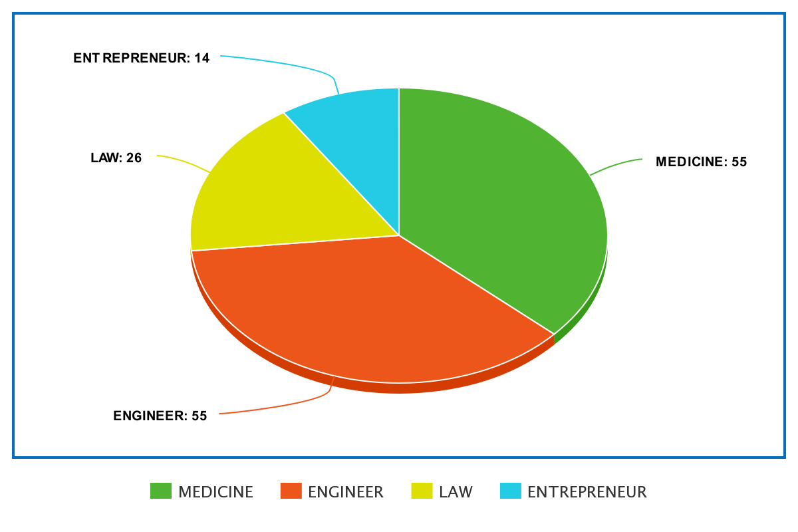

So, our group explained to them what it takes to be an engineer or a doctor.

And also, the guidance required.

* **Stay organized:** Keep track of deadlines, assignments, and appointments in a planner or calendar. Make to-do lists and prioritize tasks to ensure you stay on top of everything.
* **Focus on your studies:** Both medicine and engineering are demanding fields that require a lot of hard work and dedication. Make studying a top priority and set aside dedicated time each day to review material and complete assignments.
* **Build a strong foundation:** Make sure you have a solid understanding of the basics in your field before moving on to more advanced material. This will help you retain information better and be better prepared for exams and real-world applications.
* **Get hands-on experience:** Participate in internships, co-op programs, or research opportunities to gain practical experience in your field. This can also help you make valuable connections and build your resume.
* **Collaborate with others:** Work with classmates, colleagues, and mentors to learn from each other and build your professional network. This can also help you gain different perspectives on problems and find creative solutions.
* **Balance work and play:** While it's important to be dedicated to your studies, it's also important to maintain a healthy work-life balance. Take time for yourself, engage in hobbies and activities you enjoy, and make time for friends and family.
* **Seek support:** If you need help or guidance, don't hesitate to reach out to professors, advisors, mentors, or peer support groups. Building a support network can help you succeed academically and professionally, and can also provide you with a source of encouragement and inspiration.

And we seek the school organisation to conduct mentoring sessions, webinars and seminars by professionals so the students could get more awareness and understanding of the career fields they want to get in.

This will guide them to land their dream career more easily and could increase their chance of succeeding and fulfilling their goals.

**CHAPTER 5: RECOMMENDATIONS AND CONCLUSIONS OF THE MINI**

**PROJECT**

**Recommendations**

**Set up a Long-Term Goal:** Unfortunately, most students forget long-term happiness and think about day-to-day life management, which can lead to less-than-ideal career choices down the line. The best way to get ahead on your career guidance is to simply ask yourself what it is that you want out of life.

**Reflect on Hobbies & Extracurricular Activities:** Depending on the type of student life you’ve led; your future career path might already be hidden somewhere in your activities. Hobbies and extracurricular activities can easily be transformed into full-time jobs, career development opportunities and potential startups.

**Mind Map your Likes & Dislikes:** When it comes to career guidance, there is only so much you can do while you’re still a student. As such, mind mapping can help you discern what you like or dislike quite efficiently. In order to create a mind map, all you need is a sheet of paper, a few coloured pens and some free time to spare. Branch out your likes and dislikes into left and right and simply start writing down the things you are grateful for and their opposites. This type of self-reflection is extremely important in figuring out your future career path, as well as for discovering personal development opportunities.

**Look Beyond your Degree:** Considering a career that does not revolve around the academic degree you just attained might seem counterproductive at first. However, it makes sense given the multi-industry nature of many academic courses.

Lastly, the best thing you can do for yourself is to take it easy, graduation is just another stepping stone in life. Take your time and explore your options – there is an endless plethora of possibilities in front of you when it comes to career development. At the end of the day, if you don’t like a career path, you can easily readjust your course and try something else. Don’t compromise your dreams and don’t settle for anything less than you are worth – the right career opportunity is out there waiting for you.

**Conclusions**

Career guidance will help students fulfil their aspirations by setting up realistic goals. Career choice will determine the student’s future by providing them with their dream job and providing them a better lot with job satisfaction. Career guidance with an expert counsellor will develop a clear road map to fulfil future dreams. The key benefits of Career Guidance include gaining clarity on career goals, identifying job market trends, evaluating one's skills and competencies, gaining knowledge about various industries, and exploring different career paths. Career counselling provides an understanding of the prevailing job trends in the Indian economy. It helps individuals better understand their skills and abilities so they can make more informed career choices that suit both their ambitions and passions.

A career guidance internship can be a valuable experience for individuals looking to explore different career paths and gain practical skills in the field of career counselling and development. Through the internship, students can gain exposure to a wide range of career-related topics, such as resume writing, interview preparation, job search strategies, and more. Additionally, internships provide opportunities for networking and building relationships with professionals in the field, which can be beneficial for future career advancement. Overall, a career guidance internship can be a great way to gain hands-on experience and build a foundation for a successful career in career development and counselling. It provides an opportunity for students and recent graduates to gain hands-on experience in the field of career development and counselling. Through this internship, individuals can learn about various aspects of career guidance, such as conducting assessments, developing career plans, and providing support to individuals in their job search. The internship also allows individuals to build important skills such as communication, problem-solving, and critical thinking.

In conclusion, a career guidance internship can be a valuable investment in one's personal and professional growth. It provides a platform for individuals to develop their expertise in the field, and to gain practical experience in helping others to achieve their career goals. This experience can be invaluable in launching a successful career in career guidance, human resources, or related fields.

#### Student Self-Evaluation for the Community Service Project

**Student Name:** Bhogadi Vidhey

**Registration No:** 21025A0571

**Period of CSP:** 6-weeks (**From:** 21/11/2022 **To:** 01/01/2022**)**

**Date of Evaluation:** 13/02/2023

**Please rate your performance in the following areas:**

**Rating Scale:** 1 is lowest and 5 is highest rank

**Letter grade of CGPA calculation to be provided**

|  |  |  |  |  |  |
| --- | --- | --- | --- | --- | --- |
| 1 Oral communication | 1 | 2 | 3 | 4 | 5 |
| 2 Written communications | 1 | 2 | 3 | 4 | 5 |
| 3 Proactiveness | 1 | 2 | 3 | 4 | 5 |
| 4 Interaction ability with community | 1 | 2 | 3 | 4 | 5 |
| 5 Positive Attitude | 1 | 2 | 3 | 4 | 5 |
| 6 Self-confidence | 1 | 2 | 3 | 4 | 5 |
| 7 Ability to learn | 1 | 2 | 3 | 4 | 5 |
| 8 Work Plan and organization | 1 | 2 | 3 | 4 | 5 |
| 9 Professionalism | 1 | 2 | 3 | 4 | 5 |
| 10 Creativity | 1 | 2 | 3 | 4 | 5 |
| 11 Quality of work done | 1 | 2 | 3 | 4 | 5 |
| 12 Time Management | 1 | 2 | 3 | 4 | 5 |
| 13 Understanding the Community | 1 | 2 | 3 | 4 | 5 |
| 14 Achievement of Desired Outcomes | 1 | 2 | 3 | 4 | 5 |
| **15 OVERALL PERFORMANCE** | **1** | **2** | **3** | **4** | **5** |

**Date:** 13/02/2023 **Signature of the Student**

Evaluation by the Person in-charge in the Community / Habitation

**Student Name:** Bhogadi Vidhey

**Registration No:** 21025A0571

**Period of CSP**: 6-weeks (**From:** 21/11/2022 **To:** 01/01/2022)

**Date of Evaluation:** 13/02/2023

**Name of the Person in-charge:** Ramana sir (Head Master)

**Address with mobile number:** +91 95429 46655, beside SP office,

reserve police lines, Kakinada, 533 003.

Please rate the student’s performance in the following areas:

Please note that your evaluation shall be done independent of the student’s self-evaluation. Rating Scale: 1 is lowest and 5 is highest rank.

|  |  |  |  |  |  |
| --- | --- | --- | --- | --- | --- |
| 1 Oral communication | 1 | 2 | 3 | 4 | 5 |
| 2 Written communications | 1 | 2 | 3 | 4 | 5 |
| 3 Proactiveness | 1 | 2 | 3 | 4 | 5 |
| 4 Interaction ability with community | 1 | 2 | 3 | 4 | 5 |
| 5 Positive Attitude | 1 | 2 | 3 | 4 | 5 |
| 6 Self-confidence | 1 | 2 | 3 | 4 | 5 |
| 7 Ability to learn | 1 | 2 | 3 | 4 | 5 |
| 8 Work Plan and organization | 1 | 2 | 3 | 4 | 5 |
| 9 Professionalism | 1 | 2 | 3 | 4 | 5 |
| 10 Creativity | 1 | 2 | 3 | 4 | 5 |
| 11 Quality of work done | 1 | 2 | 3 | 4 | 5 |
| 12 Time Management | 1 | 2 | 3 | 4 | 5 |
| 13 Understanding the Community | 1 | 2 | 3 | 4 | 5 |
| 14 Achievement of Desired Outcomes | 1 | 2 | 3 | 4 | 5 |
| **15 OVERALL PERFORMANCE** | **1** | **2** | **3** | **4** | **5** |

**Date:** 13/02/2023  **Signature of the Supervisor**

**PHOTOS & VIDEO LINKS**

**Drive link:** <https://drive.google.com/drive/folders/1LUIgPCyyBHuW1SJkyKibtqT59I1a3Hlj?usp=sharing>

**Scan Code:**



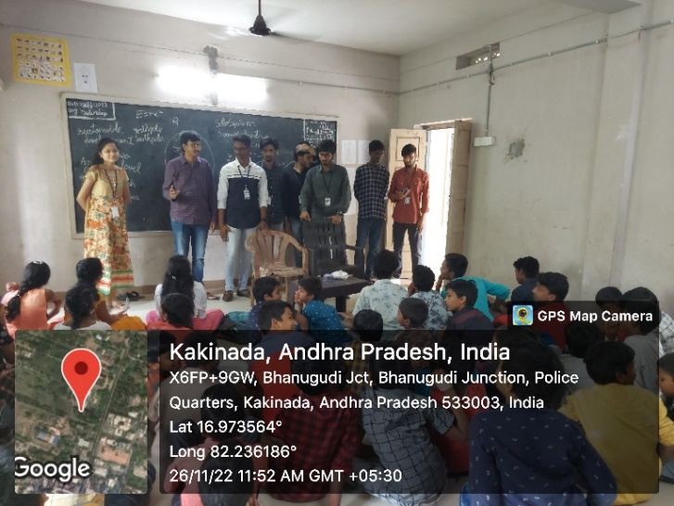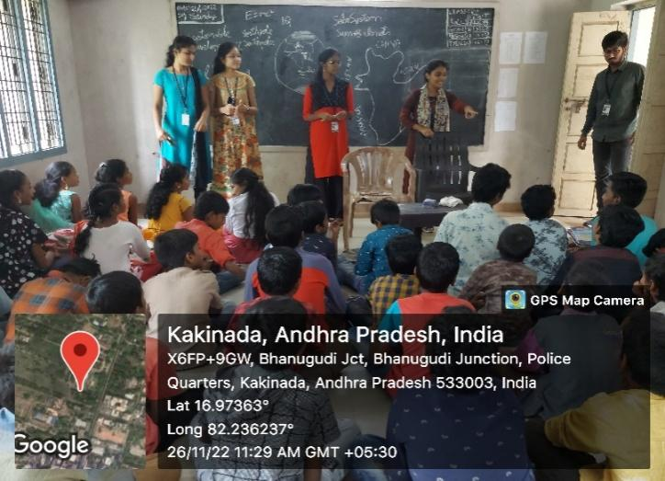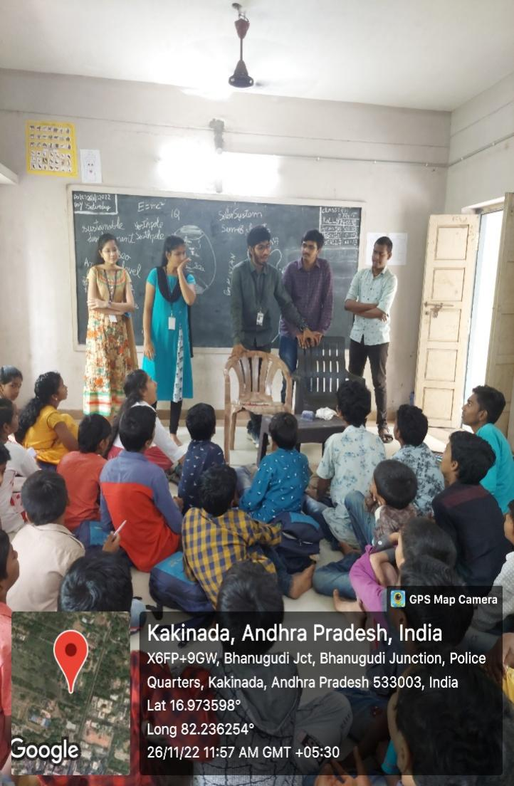**PHOTOS**

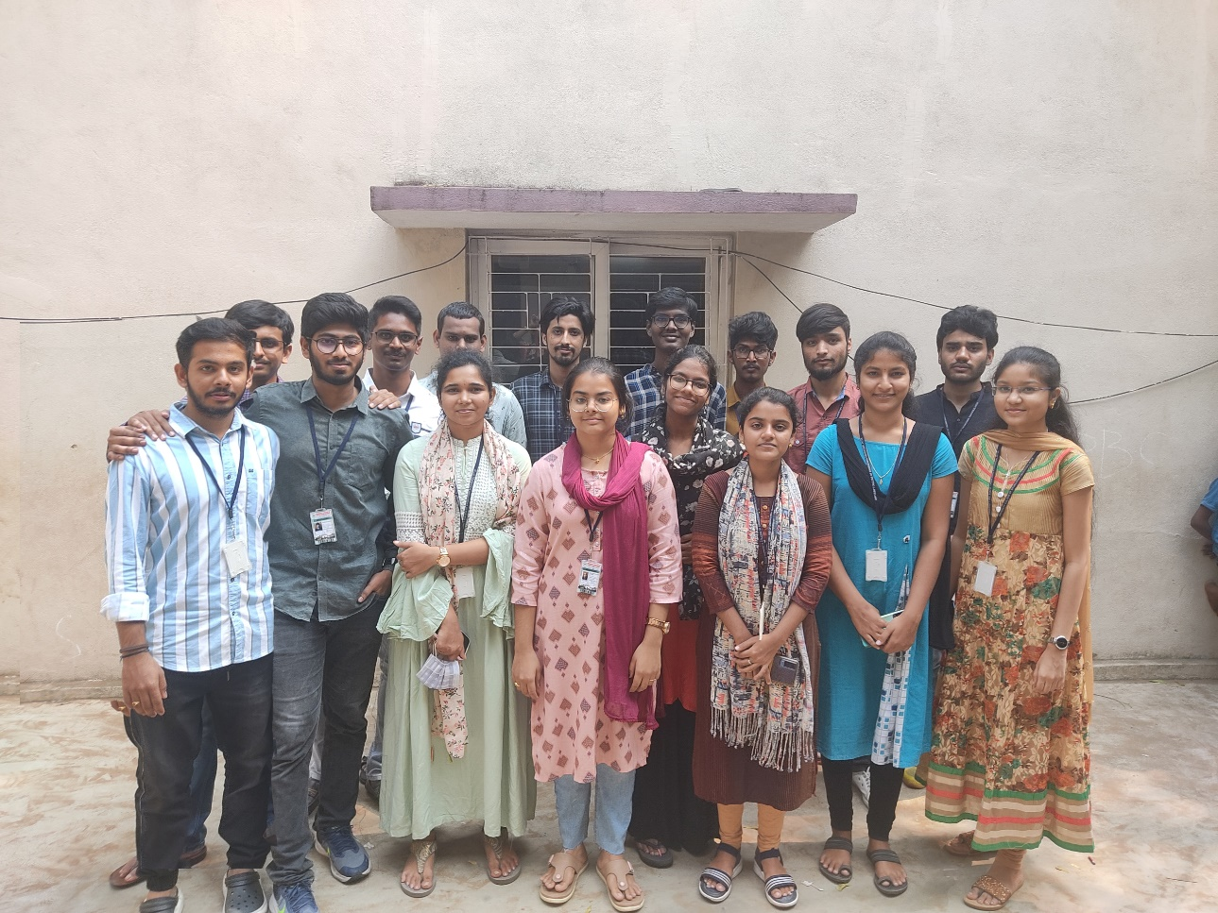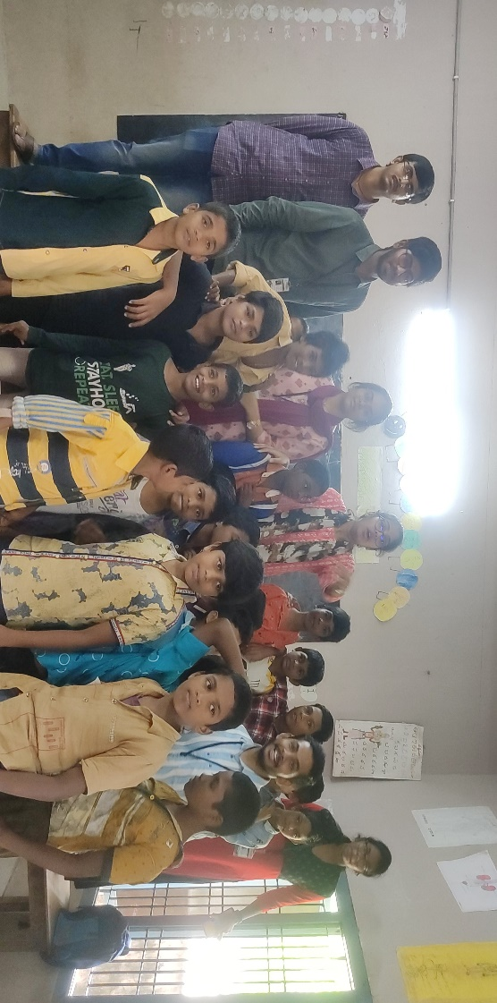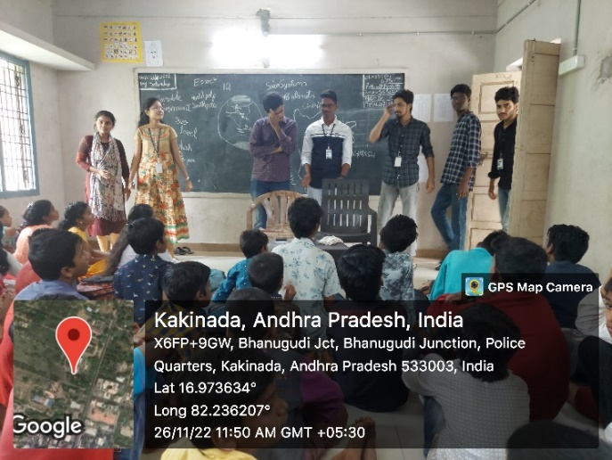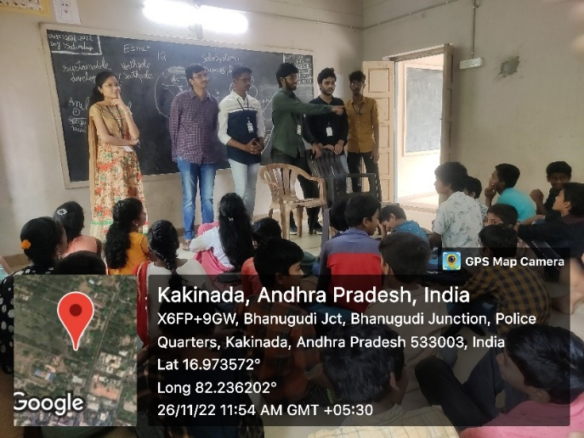

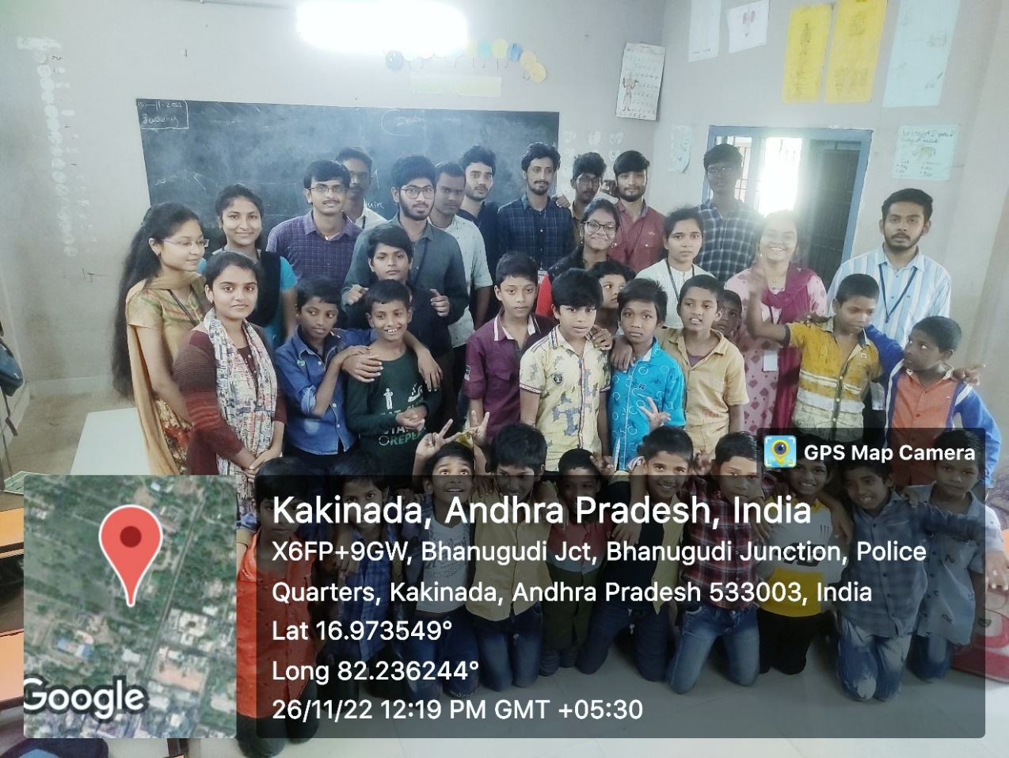

**Note:** For more details, please visit <https://cspweb.netlify.app/> or scan the

following code.



# EVALUATION

**Internal Evaluation for the Community Service Project**

**Objectives:**

* To facilitate an understanding of the issues that confront the vulnerable / marginalized sections of society.
* To initiate team processes with the student groups for societal change.
* To provide students an opportunity to familiarize themselves with the urban / rural community they live in.
* To enable students to engage in the development of the community.
* To plan activities based on the focused groups.
* To know the ways of transforming society through systematic programme implementation.

**Assessment Model:**

* There shall only be internal evaluation.
* The Faculty Guide assigned is in-charge of the learning activities of the students and for the comprehensive and continuous assessment of the students.
* The assessment is to be conducted for 100 marks.
* The number of credits assigned is 4. Later the marks shall be converted into grades and grade points to include finally in the SGPA and CGPA.
* The weightings shall be:

o Activity Log 20 marks

o Community Service Project Implementation 30 marks

o Mini Project Work 25 marks

o Oral Presentation 25 marks

* Activity Log is the record of the day-to-day activities. The Activity Log is assessed on an individual basis, thus allowing for individual members within groups to be assessed this way. The assessment will take into consideration the individual student’s involvement in the assigned work.
* While evaluating the student’s Activity Log, the following shall be considered
  1. The individual student’s effort and commitment.
  2. The originality and quality of the work produced by the individual student.
  3. The student’s integration and co-operation with the work assigned.
  4. The completeness of the Activity Log.
* The assessment for the Community Service Project implementation shall include the following components and based on Weekly Reports and

**Outcomes Description**

* 1. Details of the Socio-Economic Survey of the village/habitation.
  2. Problems identified.
  3. Community Awareness Programs organized.

e. Suggested Short-Term and Long-Term Action Plan.

## MARKS STATEMENT

**(To be used by the Examiners)**

**INTERNAL ASSESSMENT STATEMENT**

**Name Of the Student:** BHOGADI VIDHEY

**Programme of Study:** R20

**Year of Study:** IIIrd year 1st semester

**Group:** Computer Science & Engineering

**Register No:** 21025A0571

**Name of the College:** Jawaharlal Nehru Technological University

|  |  |  |  |
| --- | --- | --- | --- |
| **Sl. No** | **Evaluation Criterion** | **Maximum Marks** | **Marks Awarded** |
| 1. | Activity Log | 20 |  |
| 2. | Community Service Project Implementation | 30 |  |
| 3. | Mini Project Work | 25 |  |
| 4. | Oral Presentation | 25 |  |
|  | GRAND TOTAL | 100 |  |

Date: 13/02/2023 **Signature of the Faculty Guide**

### Certified by

Date: 13/02/2023  **Signature of the Head of the Department**

Seal:

